**Soluble Root Exudate Collection Protocol (LDRD 11146)**

John Field, Environmental Sciences Division, Oak Ridge National Laboratory

[FieldJL@ornl.gov](mailto:FieldJL@ornl.gov)

(317) 748-9792

Written: 10/03/2022

Developed under Research Safety Summary (RSS) 9119

Updated to version 6: 9/15/2024 (JLF)

**Overview:**

This protocol is designed for the collection of soluble root exudates *in situ* in field or greenhouse settings to support measurement of exudation rate and chemistry/ metabolomics. In brief, fine roots are carefully excavated from the soil, allowed to recover, then incubated in a dilute nutrient salt solution for approximately one day. Exudate samples are recovered by flushing fresh nutrient solution through the incubation assembly; flush solution samples are then collected, filtered, frozen, and returned to the lab for measurement of total organic carbon (TOC) and liquid chromatography–mass spectrometry (LC–MS) chemical analysis. In addition, the incubated roots are recovered, scanned, and weighed in order to normalize the rate of exudation against the root mass, volume, surface area, etc.

There are only very limited examples of field root exudate collection for metabolomic analysis in the existing literature, and associated methods vary widely. This protocol was modified from Phillips et al. 2008. *Functional Ecology* 22(6) 990–999 by Rose Abramoff, and subsequent changes were informed by an informal literature review conducted by Abramoff and John Field, summarized here: [https://docs.google.com/spreadsheets/d/1knX6Bz8RmeoAcph9IfCfVKZadpAyQil7qGnWULf8sH0/edit#gid=0](https://docs.google.com/spreadsheets/d/1knX6Bz8RmeoAcph9IfCfVKZadpAyQil7qGnWULf8sH0/edit" \l "gid=0). Changes from the original Phillips et al. 2008 protocol include simplifications designed to save time or costs, to better support metabolomic analysis, and to improve safety. There are several considerations in past and ongoing protocol adaptation and optimization:

* **Protection of root function—**The goal of this protocol is to collect exudates from roots *in situ* (in the field or from potted plants in the greenhouse) while minimizing disturbances that could change the rate or chemistry of exudation and rhizodeposition. Initial root excavation from the field soil or greenhouse potting mix should be done very carefully to minimize abrasion and/or breakage of root tips—***this is typically the most labor-intensive part of the protocol by far***. The protocol includes a rest/recovery step between excavation and incubation to allow the roots to recover from that disturbance and return to equilibrium function. Once roots are carefully placed in incubation assemblies, those containers are backfilled with glass beads to mimic physical structure of soil and provide some air-filled pore space for gas exchange. Also, this protocol follows the original Phillips et al. method of incubating the live roots in a mild nutrient salt solution, to keep a realistic osmotic balance and stimulate solution uptake by the roots. This contrasts with some more recent exudate metabolomic studies that sterilize the roots prior to incubation and/or incubate them in pure DI water. DI water collection would be compatible with GC–MS analysis in the Tschaplinski lab, but the salty nutrient solution requires LC–MS analysis (Paul Abraham).
* **Contamination & controls—**This protocol is meant to support collection of root exudates, rather than root biomass, soil, or other contaminants. The protocol involves multiple rinsing steps to remove soil from roots, and to flush any remaining soil or other contaminants from the incubation assemblies. Exudate samples are also filtered to remove any particulate contaminants prior to analysis. While utilizing acid-washed glass incubation containers and other components would be ideal for avoiding any leaching of carbon-containing compounds from the incubation assemblies into the exudate samples, cost and time considerations require the use of plastic components. The glass beads used to mimic soil structure should ideally be acid-washed prior to use. In addition, controls samples should be collected to better characterize and correct for potential contamination. Nutrient solution control samples with and without intentional soil contamination should be collected during any field sampling campaign. Future protocol optimization should attempt to quantify potential sources of contamination, particularly from the polyvinyl difluoride (PVDF) syringe filters used for filtering these samples. Nutrient blank solutions collected during the initial Clatskanie field campaign showed ~2 ppm TOC, significant compared to the main F1 (6–45 ppm TOC, median=13ppm) and F2 flush samples (2–14 ppm TOC, median=5).
* **Sample storage & preservation—**We generally store samples collected in the field on ice packs (“blue ice”) in a cooler, until they can be put into a –80C freezer back at the lab. Some secondary metabolites (e.g., auxin) present in root biomass and exudates are short-lived, and capturing those transient compounds would require immediate and continuous ultra-cold handling and storage. Also, Tim Tschaplinski and Nancy Engle have observed hydrolytic activity during insufficiently cold sample storage that leads to loss of oligosaccharides and complex phenolics in favor of greater monosaccharides and cleaved aromatics. The nature of this exudate collection method—i.e., day-long incubation at ambient temperature—makes such transformations inevitable. However, if fine root biomass is collected at the same time for metabolomic analysis, it is recommended those samples be stored on dry ice immediately (requires additional training and planning steps). Note that glass scintillation vials will likely crack during –80C storage, and plastic centrifuge tubes will crack if over-filled. Care should be taken to order deep-freeze-friendly sample storage containers, and not to over-fill them.
* **Miscellaneous considerations—**The protocol below tries to minimize the “dead” volume of incubation solution that is not in contact with roots by using narrow tubing. Luer lock components and parafilm (rather than the plastic stoppers described by Phillips et al.) are used where possible to keep a closed system and minimize soil contact with incubation assemblies. For simplicity we have generally adopted three initial rinse steps to remove any contaminants from the incubation assemblies (rather than the 5 done by Phillips et al.) and two flush steps to recover exudates (rather than the 3 they recommend). The original protocol relied on using needles to transfer exudate solution samples into evacuated glass sample vials, but this introduces puncture risks, and glass vial tend to crack during –80C storage prior to metabolomic analysis. To avoid these issues, we have modified the protocol to transfer samples directly to 15 mL plastic conical tubes, though this introduces an additional opportunity for soil contamination of the samples.

This protocol has been utilized in both field and greenhouse settings. Abramoff, Field, and Sarah Ottinger sampled ~50 mature back cottonwood trees (*Populus trichocarpa*) at the CBI GWAS site in Clatskanie, Oregon in mid-October, 2022. In addition, Field, Udaya Kalluri, and Tommy Mead further modified the protocol to collect exudates from 20 trees grown in the APPL greenhouse in early June, 2024.

**Time requirements:**

* This is ideally a minimum three-day field protocol. On the first day, a fine root bunch is carefully excavated, and then allowed to recover in moist sand for a day. On the second day, the roots are loaded into incubation assemblies, rinsed, and a day-long incubation is initiated. On the third day the incubation solution is recovered.
* During the Clatskanie field campaign, it took 3 people about (6) 8-hour days to collect ~50 samples, or **~3 hours per sample**. This time was especially long because dry conditions made excavation slow, we were very conservative about root tracing and minimizing root damage, and the disperse site required a lot of walking between the trees being sampled.
* During the APPL greenhouse campaign, it took an average of two people (2) 5-hour days to collect 20 samples, or **~1 hour per sample**. In this case, root excavation was relatively quick compared to the field, and the root recovery step was skipped entirely due to impracticality and lack of time.

**Materials & equipment:**

* PPE
  + Gloves—several pairs per person per day, in the appropriate sizes (should be used any time plant material that could have been exposed to fertilizers or pesticides is handled)
  + Bug spray
  + Sunscreen
  + Gardening pads (to make extended kneeling more comfortable)
  + Tarp (to separate from wet ground and insects)
  + Plenty of drinking water
* Tools for excavation
  + Hand trowels
  + Assortment of tweezers
  + Small paintbrushes (for brushing soil particles from fine roots)
* Marker flags (one per tree to be sampled)
* Flagging tape
* Pie tins (2 per plant)
* Sand (~1/2 pound(?) per tree sampled; used in root recovery step)
* Tap water in squirt bottles (for rinsing roots, and rinsing gloves and other components to minimize soil contamination)
* Paper towels (for blotting roots and general cleaning)
* Incubation assembly—one assembly per plant sampled, plus several extra to collect **control samples**. Quantities listed below are **per plant sampled:**
  + (2) 30 mL plastic luer lock syringes (used for root incubation and solution flushing/collection), plus addition
    - Greenhouse variation described below calls for smaller 20 mL syringes due to space constraints and smaller root sizes; see below
  + Mesh or screen material to prevent glass beads from clogging syringe port
    - The original protocol used mesh fabric cut in disks or folded into cones
    - Stainless steel pipe screens greatly simplify set-up and improve reliability
  + Glass beads
    - (~15 mL / 1 oz) 3 mm coarse beads to take up space
    - (~15 mL / 1 oz) 1 mm fine beads to provide more realistic support and porosity
      * Phillips et al. used 750 μm diameter
      * 1 lb of beads = 215 mL; 15 mL = 0.07 lb = 1.1 oz.
    - Stored in squirt bottles for easier pouring
    - It is difficult to get good mixing between the 1mm and 3mm beads in the incubation assemblies. We should consider using 1mm beads only, or a slightly smaller size instead of 1mm, or layering the two sizes more carefully while filling the incubation syringe.
  + (1) syringe filter (PVDF, 33mm diameter, 0.22 μm pore size)
    - We should explore this as a potential source of TOC contamination, and potentially test alternative materials, and/or pre-rinsing the filters.
  + (1) three-position stopcock
    - Facilitates rinsing and flushing, recovering of all solution
  + 15 cm of 1/16” inner diameter Tygon tubing
    - This narrow tubing size minimizes dead volume in the assembly
  + Barb adaptors—(1) female luer to 1/16” barb and (1) male luer to 1/16” barb
* Parafilm
* Tinfoil
* Scissors
* Dilute nutrient salt solution
  + (3) 15 mL rinses + (2) 10 mL incubation/flushes = 65 mL per plant sampled
  + Stored in squirt bottles, or more ideally with some sort of luer fitting
  + Optional– When working at remote field sites, nutrient solution can be prepared and shipped in a 10x concentrated form, and then diluted down in the field. Doing so requires a source of distilled water and a plastic graduated cylinder.
* Sample containers
  + (1) 30–40 mL freeze-proof tubes per plant sampled, for storing F1 and F2 samples
  + It may be justified to pool both F1 and F2 samples into a single 50 mL conical sample tube instead, to limit the number of TOC and LC–MS measurements required.
* Cooler with ice packets (“blue ice”) for preservation of collected samples
  + We may switch to preserving samples on dry ice in the future, but this requires additional training and planning
* 5-gallon buckets (for collecting waste sand and other trash)
* Optional– Plastic baggies for soil moisture sample collection
* Optional– Whirl bags for collecting additional fine root biomass samples
* Optional– Coin envelopes for storing/drying incubated roots back at the lab

**Preparation:**

* **Nutrient solution stock**—Get a 1L volumetric flask and fill about ¾ths with nanopure water (in the analytical room). To this, add the following chemicals found in the chemical cabinet:
  + 0.4g NH4NO3
  + 0.136g KH2PO4
  + 0.349g K2SO4
  + 0.181g MgSO4 (anhydrous, FW= 120.37)
  + 0.441g CaCl2 (hydrated, FW= 147.02)

Put a stirbar (in a jar above the balances) in the flask and stir until everything has dissolved. Filter the solution with a vacuum Erlenmeyer flask and the glass filtering apparatus. Filters for this are the 47mm ones. Store the stock solution in a plastic Nalgene in the refrigerator.

* To make the working nutrient solution for the field, dilute the stock 10x (i.e., 100ml stock + 900 ml nanopure water). Store working solution in the refrigerator when not using it.
* **Acid wash the glass beads—**Use a vacuum filter flask assembly and 10% HCl (same as in Building 1505 Lab 271 acid bath)
  + **Note:** We currently use sterile syringes, tubing, stopcocks, etc. straight from the package, without any washing step. Gloves should be worn when handling those components to avoid contamination.
* **Sample container labeling—**Once the sample collection plan is established, create labels for:
  + The 30 mL syringes used in the incubation assemblies
  + The F1 and F2 sample tubes
  + Coin envelopes for storing/drying the fine roots recovered from the incubation apparatus
  + Plastic baggies for soil moisture samples
  + Any whirl bags for fine root samples
* [Need to add a data collection sheet template?]
* **Incubation container assembly—**Wear gloves to avoid contaminating any components. Drop a stainless steel pipe screen to the bottom of the syringe body. Add ~3 mL of coarse glass beads, and re-insert the syringe plunger to hold the mesh/screen and beads in place (Figure 1). Cut a ~15 cm length of **NEW** tygon tubing, and attach a female luer adaptor to one end and a male luer adaptor to the other (Figure 2). Remove the plugs from the two female sockets of the three-position stopcock. Attach one socket to the syringe, and the other to the tygon tubing assembly. Leave the make socket plugged, so incubation fluid cannot accidently drain out when operating the valve.

**Root excavation, cleaning & recovery:**

This is the most painstaking and time-consuming step in the process. Root excavation and cleaning in the field can take an hour or more, particularly when conditions are dry and the soil is firm. Note that if you are attempting to sample individual trees in a common garden setting, it is ***essential*** to trace roots out from the target tree, since there will likely be large amounts of root intermingling. A good fine root bunch should include multiple live (light-colored and firm) branches, with root tips intact, over a length of 3–5 inches (Figure 4). It is common to start excavating multiple candidate fine roots, only to find that they are unacceptable (e.g., too short, or damaged, or diving too deep into the soil), before completing a successful excavation of an appropriate fine root bunch.

* **Excavation—**Use flagging tape to mark the tree being sampled.Scrape any litter layer or live groundcover away from the plant stem. Dig near the plant stem to identify a wide radial root, and follow it until a live fine root (2mm or less in diameter branches off) is found. Take extreme care to avoid damaging any of the upstream root system, or sever the fine root being excavated. Use tweezers and your fingers to follow and gently excavate the roots branching out from that fine root, until the entire root bunch is completely excavated. Sometimes a hand trowel can be used to dig out the soil beyond when you estimate the end of the root bunch lies, and then excavating backwards toward the target root. This is a very delicate process, and you should use your fingers to tug at the fine roots, but minimize force so that you don’t break off the fine root tips (hot-spots for exudation?). Use a flag to mark the approximate position of the excavated root.
* **Cleaning—**Using forceps, gently clean organic material and soil from the root. It can also be helpful to soak the root in a foil pan filled with water. We usually finish the cleaning by rinsing the root on a paper towel with a tap water squirt bottle. Figure 4 shows an example cleaned root bunch. Record any notes on the root in the field notebook.
* **Recovery—**Once the root is clean, dig a depression and place a foil pan with holes in the bottom in the depression (if you have extra time, you can dig this hole out deeper, approximately the depth of the cuvette standing on end, to prepare for day 2). Cover the bottom of the pan with sand-soil mix from the bucket and place the root on top of this. Fill the pan the rest of the way with sand-soil mix. Put some sand-soil mix on where the root enters the pan just outside of the pan to help you identify where the root coming from when you take it out of the pan a few days later. Liberally squirt tap water over the top of the sand-soil mix until it is fully saturated. The excavated root should ideally now be completely covered in moist sand (Figure 5). Place another inverted foil pan on top to protect from heat and evaporation, and sprinkle leaf litter on top of the pan to hide it from curious animals.

**T0—Loading roots into the incubation assembly, rinsing, and initiating the incubation**

This step should be initiated only after the excavated roots have spent one or more days recovering in the sand-soil mix. Before beginning, take two new 30 mL syringes, and label one “clean” and the other “dirty”, to be used for supplying and withdrawing rinse solution to and from the incubation assemblies. These clean and dirty syringes can be re-used for rinsing out multiple incubation assemblies, though you should replace the “clean” syringe if the tip or barrel becomes obviously contaminated with soil.

* Carefully remove the leaf litter from on top of the foil pan and scoop the root out of the moist sand-soil mixture. Dump the foil pan and sand-soil mix back into the waste bucket. Place the root in a foil pan without holes in it and soak it in tap water. Then transfer it to a paper towel and rinse it with a squirt bottle and use forceps to get the rest of the sand-soil mix off.
* If you didn’t do this at the initial excavation stage, use the trowel to dig a deep hole for the incubation assembly to sit as upright as possible in.
* **Load root into the incubation assembly—**Remove the plunger from the incubation syringe and discard. Be sure to keep the syringe assembly upright so the beads and mesh/screen don’t fall out. Place the clean fine root bunch into the syringe body, ideally away from the walls (Figure 6). For longer roots, you may have to gently fold them over to fit within the syringe body. Fill the rest of the syringe volume with glass beads, alternating between layers of coarse (3mm) and fine (1mm) beads, and gently tapping the syringe body so that the beads settle in with minimum voids (Figure 7). Use parafilm to cover the open top of the syringe body around the root. The parafilm should be extensive enough to keep soil and other contaminants out of the incubation apparatus, but not air-tight (since we will need to inject and withdraw solution from the assembly, and to avoid putting too much pressure on the root).
* **Rinse—**Use the “clean” syringe to inject 15 mL of nutrient solution through the tubing and stopcock into the incubation syringe body (from the bottom; Figure 8), and close the stopcock. Disconnect the “clean” syringe and connect the “dirty” syringe. Open the stopcock, and suck out the rinse solution. Rinse solution can be discarded onto the ground away from the excavated root, or down the drain in the 1503 headhouse. Repeat this process two more time, for a total of (3) 15 mL rinses. To reduce waste and costs, these “clean” and “dirty” syringes can be re-used multiple times, provided they don’t get mixed up, and the clean syringe doesn’t become visually contaminated.
* **Initiate the incubation—**Add 10 mL of nutrient solution to the incubation assembly. Using the same “clean” syringe, inject 5 mL of air into the bottom of the assembly to help distribute the incubation solution evenly through the incubation assembly. Close the stopcock, remove the injection syringe, and cover the end of the tubing with tinfoil to keep soil out of the assembly (Figure 9).
* Record the time, the amount of incubation solution added, and any notes in the log book.
* Take a large piece of foil and wrap it around the front of the cuvette to keep the root out of the light. Put a pie tray and/or leaf litter on top of the assembly to protect it from the sun and from curious animals.

**T24—Collecting exudate samples:**

Roots should incubate for approximately 24 ± 2 hours. Since some of the original incubation solution will have been taken up by the roots, additional solution must be added to mobilize and “flush” the remaining solution and any exuded compounds out of the incubation assembly for recovery. Two separate flushes are performed, to maximize the recovery of soluble exudates accumulated in the incubation assemblies. Note that a fresh 30 mL syringe should be used to collect the flushes from each plant sampled to prevent cross-contamination, but the collection syringe can be re-used for the first and second flushes.

* Record the time that the incubation is terminated (this will allow calculation of the total incubation time), and uncover the incubation assembly.
* **First flush (F1)—**Using the “clean” syringe, add 5 mL of fresh nutrient solution through the bottom of the incubation assembly. Make sure to close the stopcock when switching between the injection and sampling syringes, so the solution does not drain out unintentionally. Then, using a fresh 30 mL syringe dedicated to collecting samples from this particular plant, withdraw as much of the incubation solution as possible. Disconnect the sampling syringe from the incubation assembly, holding it upside-down, so none of the flush solution leaks out during the transfer. Attach a syringe filter to the end of the sample syringe, and squirt the solution to the appropriately-labeled (F1) 15 mL conical sample tube (Figure 10). Be careful not to transfer any soil into the sample tube from dirty gloves or other sources. Record an estimate of the volume and color of the solution (e.g., no color, light yellow, yellow, dark yellow).
  + **Note:** earlier versions of this protocol called for using a needle to transfer the solutions to evacuated glass sample tubes with septa. While that minimized any potential for soil contamination at the sample transfer stage, it also introduced a sharps hazard, and glass sample tubes are problematic for ultra-cold storage.
* **Second flush (F2)—** Using the “clean” syringe, add 10 mL working nutrient solution through the bottom of the incubation assembly, and the inject 5 mL of air to help distribute the solution evenly. Make sure to close the stopcock when switching between the injection and sampling syringes, so the solution does not drain out unintentionally. Then, using the sampling syringe from the first flush, withdraw as much of the incubation solution as possible. Disconnect the sampling syringe from the incubation assembly, holding it upside-down, so none of the flush solution leaks out during the transfer. Attach a syringe filter to the end of the sample syringe (the filter from the F1 flush can be re-used, if it is not plugged up), and squirt the solution to the appropriately-labeled (F2) 15 mL conical sample tube. Be careful not to transfer any soil into the sample tube from dirty gloves or other sources. Record an estimate of the volume and color of the solution (e.g., no color, light yellow, yellow, dark yellow).
* **Storage—**Transfer the F1 and F2 sample tubes to the cooler with ice packs (“blue ice”).
  + In the future, we may switch to storage on dry ice (which requires additional safety protocols and planning).
* Cut the incubated root about an inch away from syringe body, and place the incubation assembly upright in a box to bring it back to the lab.

**Controls & other measurements:**

For every several incubations, control samples should be collected. In those cases, two additional incubation assemblies should be set up alongside the main incubation. These controls should be assembled and flushed just like a true incubation, but without the addition of a fine root bunch. In the “soil” control, intentionally add a small soil particle to the assembly before closing it with parafilm. After 24 hours of incubation, recover F1 and F2 flush samples, then discard the (root-less) incubation assemblies.

* **Soil moisture—**Exudation rates and chemistry are strongly affected by soil moisture condition. To better account for this, it is recommended to collect a spade-full of soil from the wall of the hole you have excavated into a labeled plastic baggie, for measurement of gravimetric water content back at the lab.
* **Fine roots—**At the time of exudate sampling, consider also collecting additional fine roots biomass samples for chemical or metabolic analysis. This provides an opportunity for comparison of the root biomass vs. exudate metabolomic profiles, or other analysis. If the root biomass will be used for metabolomic analysis, it should ideally be stored on dry ice immediately after collection.

**Processing back at the lab:**

* Put all exudate flush samples in –80C freezer until hand-off for LC–MS and TOC measurement
* **Incubation disassembly—**Remove the parafilm and gently pour the root and glass beads into a tub. If it doesn’t slide right out, squirt some water into the cuvette to help it come out. Rinse the beads off the root using a nanopure squirt bottle. Place the root and ID tape on the piece of Styrofoam board with centimeters marked on two sides, and photograph. Then store in labeled coin envelopes.
* **Root characterization—**Work with Larry York to scan each incubated root sample and analyze with Rhizovision Explorer. Put the wet roots back into labeled coin envelopes, then dry and weigh them.

**Variations for greenhouse sampling:**

This protocol was modified to collect exudate samples from poplar plants grown in the ORNL APPL greenhouse over a ~4 week period in May 2024. This experiment included plants grown in both potting mix and field soils. In both cases we removed the root/soil “plugs” from the original pots, excavated a fine root ~2 inches below the surface from the side (Figure 11); and set up our root incubation assembly below the soil surface. We down-sized from 30 mL down to 20 mL syringes for the incubation assembly, in order to accommodate the less well-developed roots and to better fit inside the greenhouse pots. All rinse and flush volumes should be scaled down accordingly. Note that root disturbance is relatively high in this greenhouse sampling, since the roots were highly intertwined, and the excavation affects a much larger fraction of the plant’s total root biomass. We sacrificed off-target roots to excavate target ones as needed, but even then, our target roots suffered from a relatively high rate of tip-snapping during excavation. Also, we didn’t have sufficient time or a practical method for implementing a root rest/recovery step, so we skipped this step in the initial trial. In future greenhouse collections, a two-step incubation process is recommended, so that the roots can rest/recover during the first incubation, and then the true samples of interest can be collected from the second incubation.

* **Potting mix—**It was moderately difficult to rinse potting mix from the roots. Root/potting mix “plugs” tended to stay intact after removal as once piece (Figure 11). Incubation assembly could thus be buried within the existing plug, and the whole bundle reassembled into the original pot (Figure 12). Additional tubing length is required to run back out the top of the pots (Figure 13), which introduces additional “dead” volume. In future iterations, we could consider putting holes in the sides of pots for better access to the incubation assemblies.
* **Field soil—**It was relatively easy to isolate and rinse the roots. However, the lack of “plug” structure meant there was nothing to anchor the incubation assemble to during reassembly. Instead, we re-potted these plants in wide circular pots, with the incubation syringes protruding from drainage holes at the bottom (Figure 14; Figure 15). Doing so required heavy disturbance of the remaining root plug (loosening and folding it) to make it fit properly in the new pot shape, while positioning the incubation assembly appropriately. All plants suffered from some wilting during the incubation assembly set-up, but these field soil plants took significantly longer to perk back up after watering.
* **Note:** In our initial trial, I did not down-scale the volumes, and I erroneously skipped the 5 mL new solution addition for the F1 flush, so we’ll probably just pool our F1 and F2 samples together for analysis.

**Photos:**

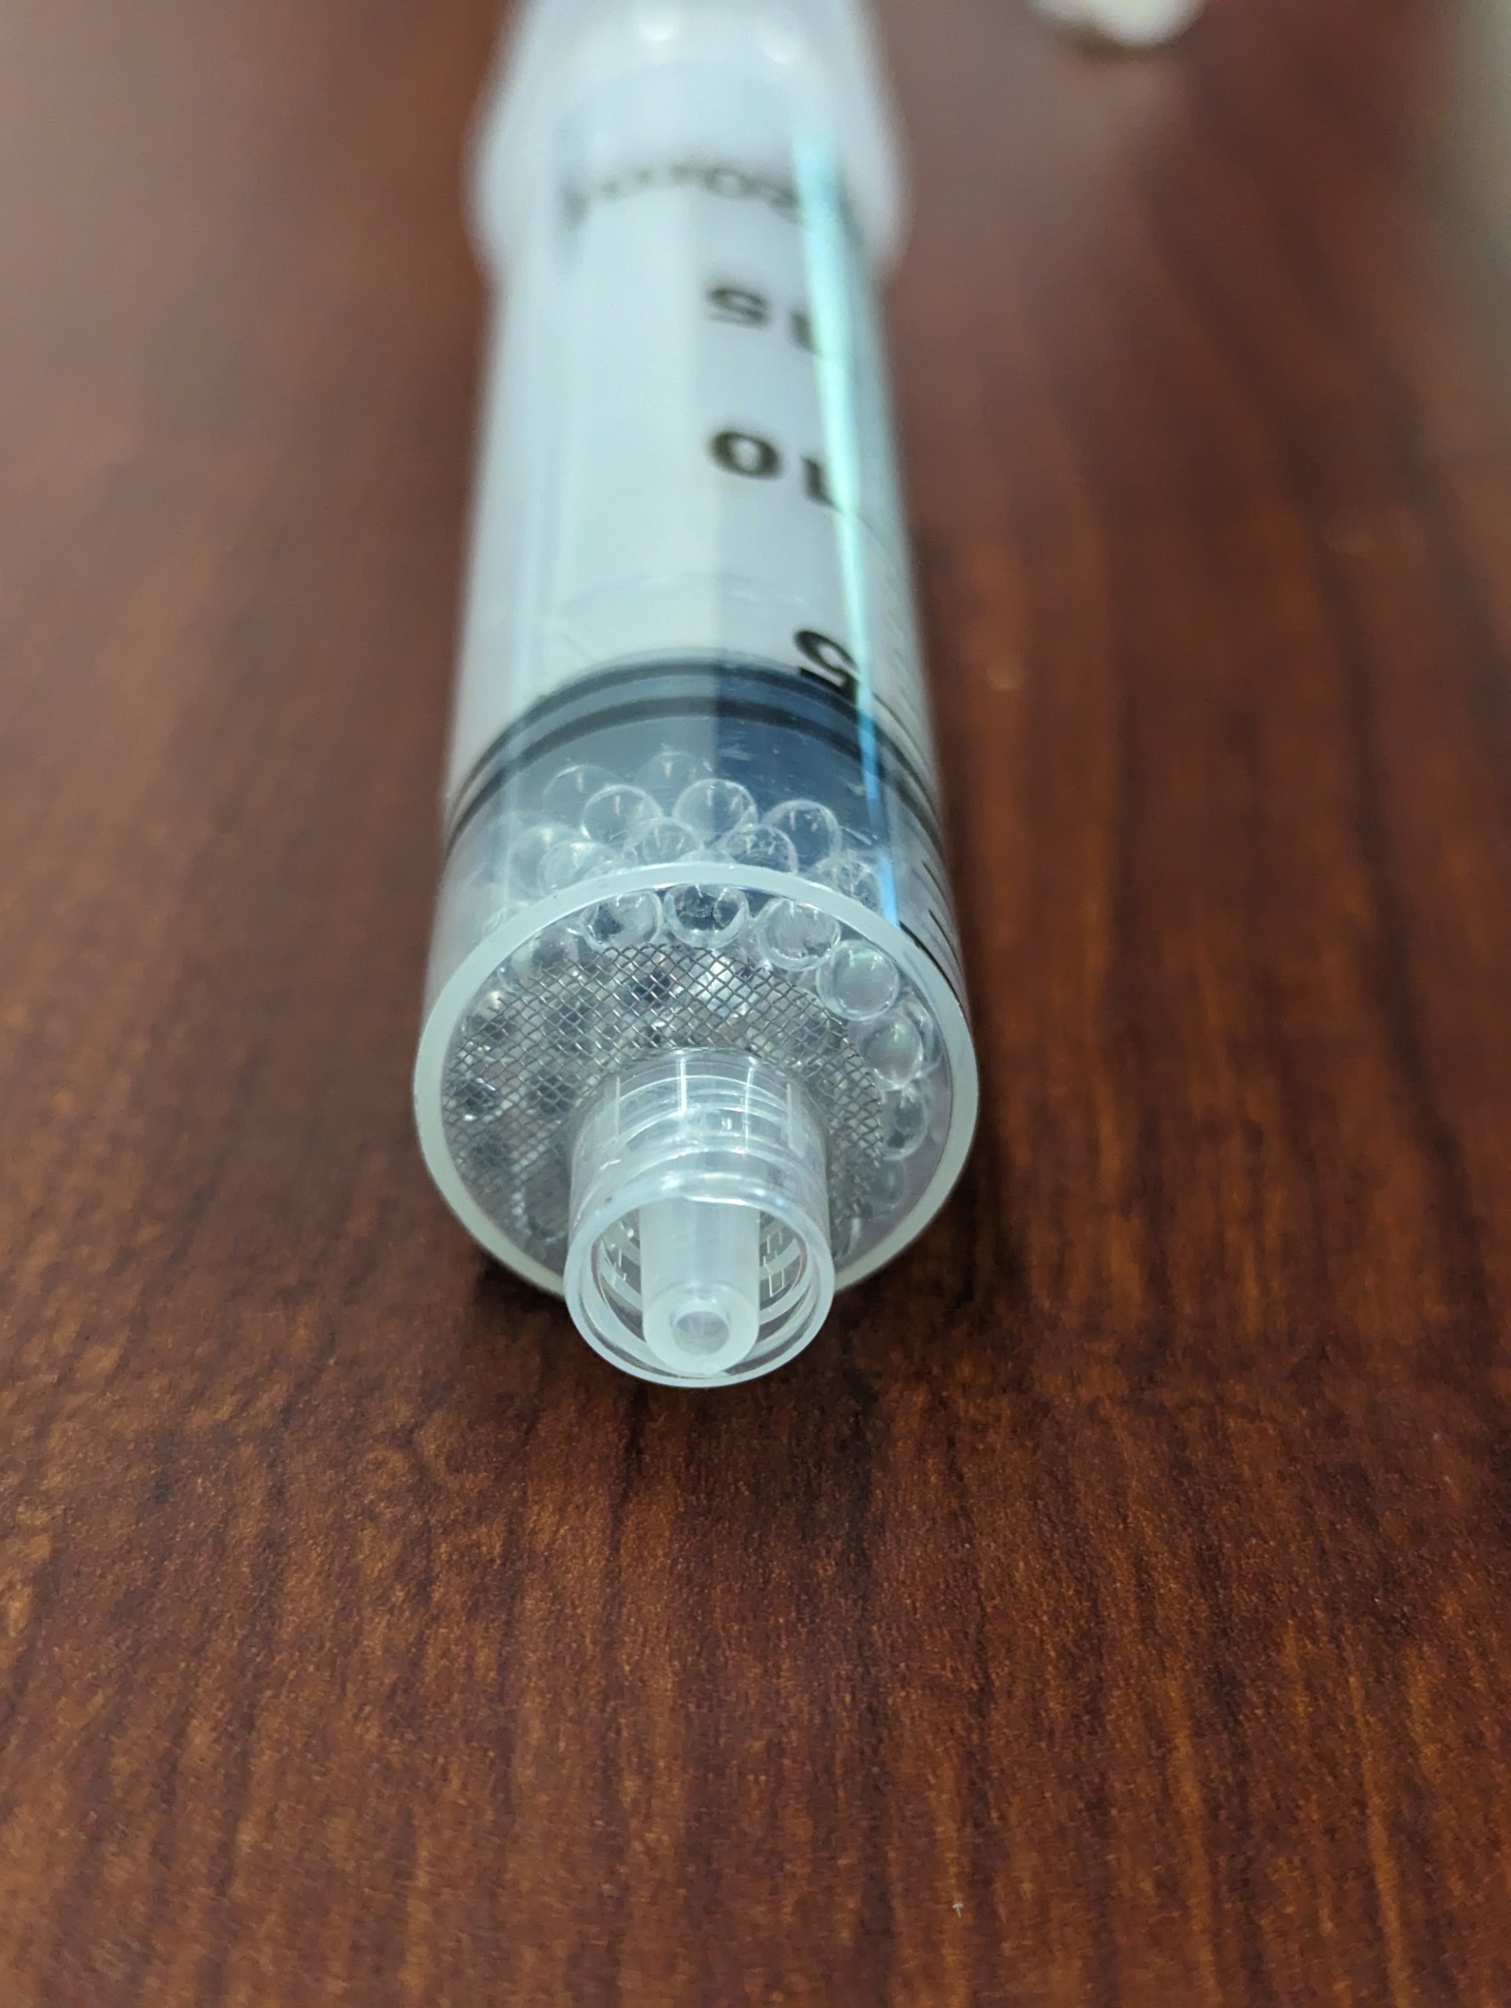

Figure 1. Stainless steel pipe screen to block glass beads from clogging syringe nozzle.

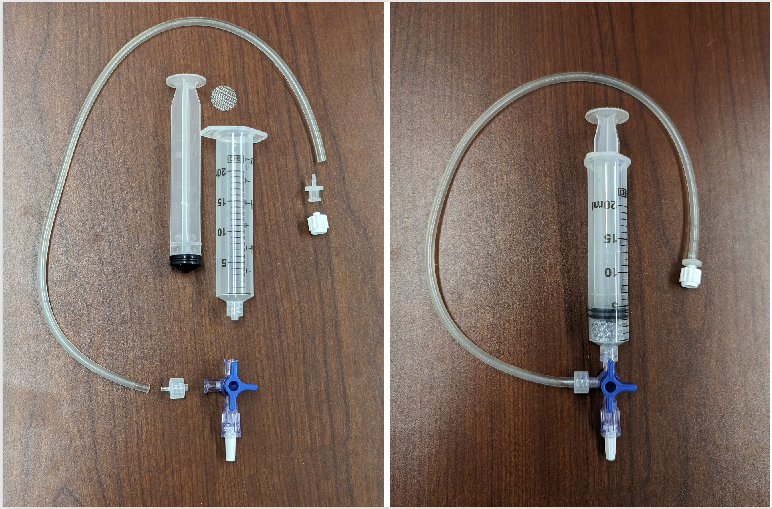

Figure 2. Incubation assembly (20 mL version).

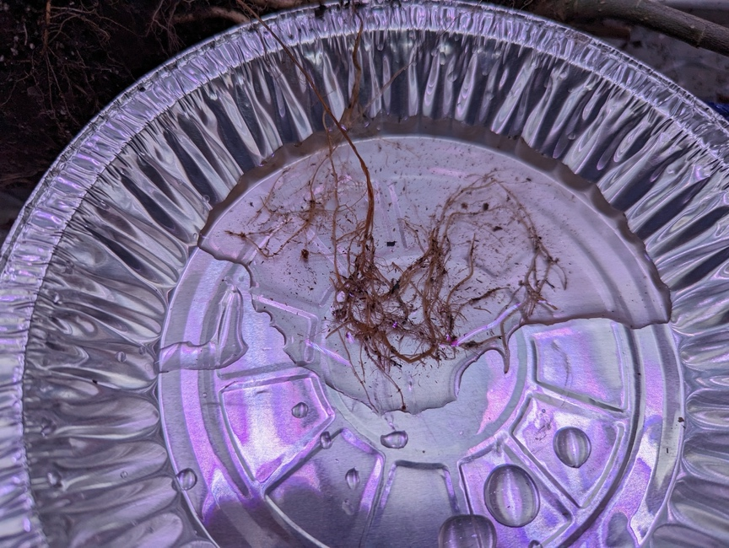

Figure 3. Soaking fine roots to help loosen and remove soil particles (or potting mix in this case).

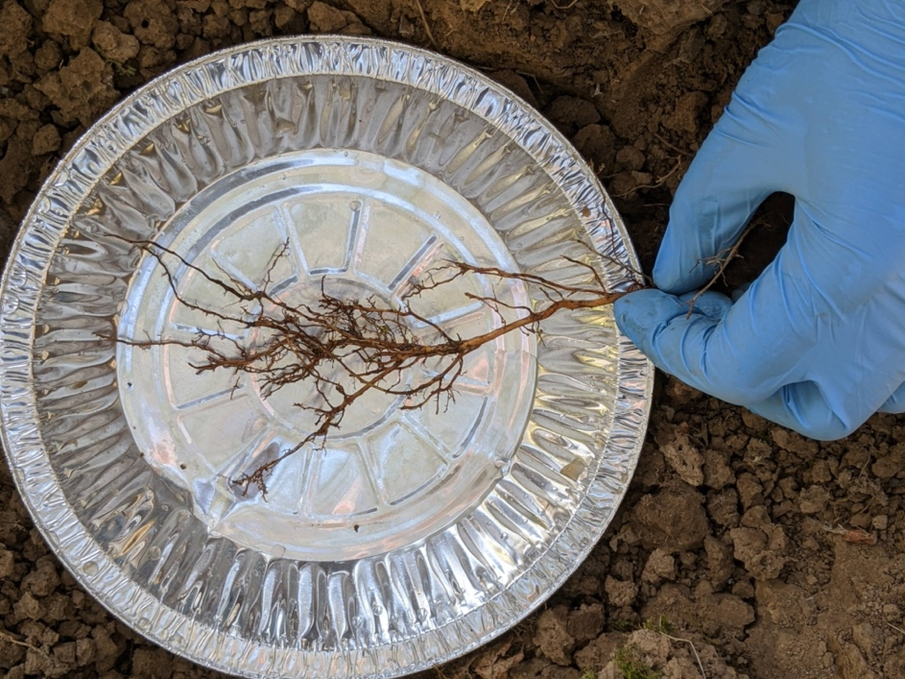

Figure 4. An excavated and cleaned fine root system (Clatskanie field site).

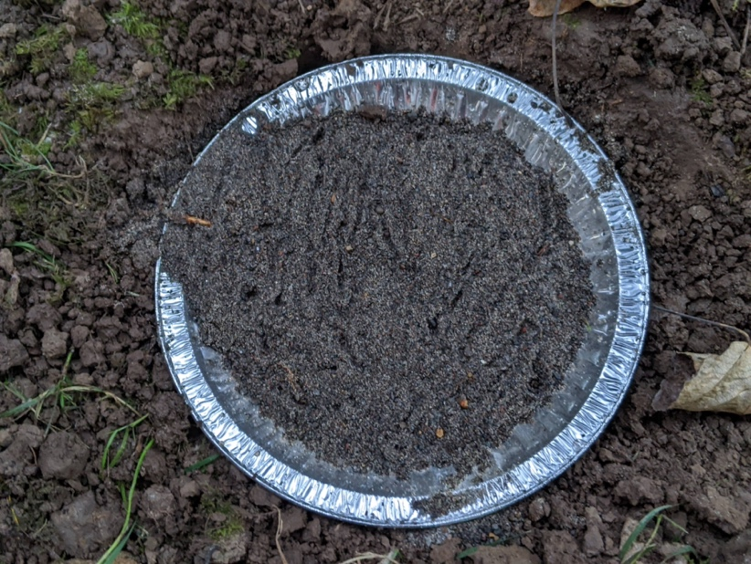

Figure 5. Root system covered in moist sand for recovery period. Note the root partially visible at 10 o'clock; the root should be as completely covered in moist sand as possible to prevent it from drying out.

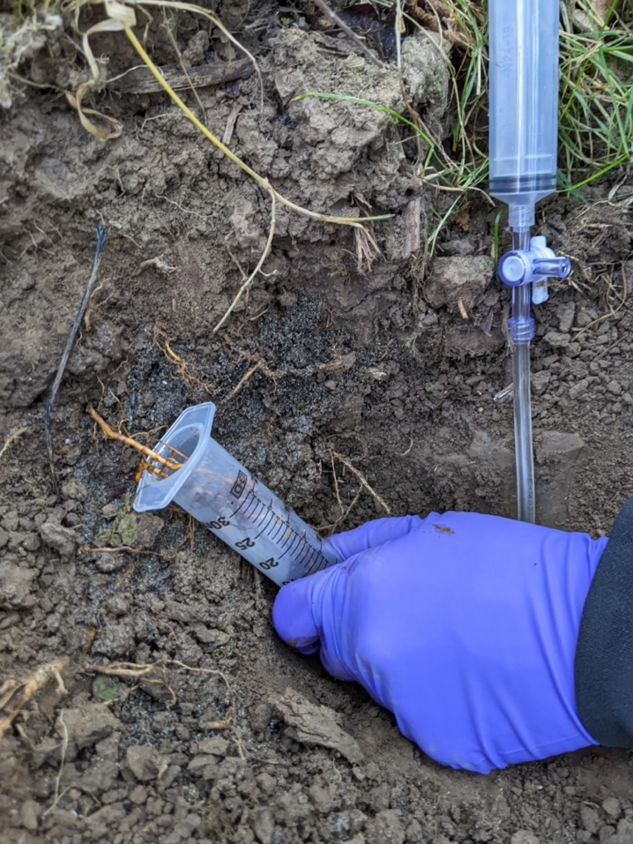

Figure 6. Loading the recovered root into an incubation assembly (30 mL syringe body).

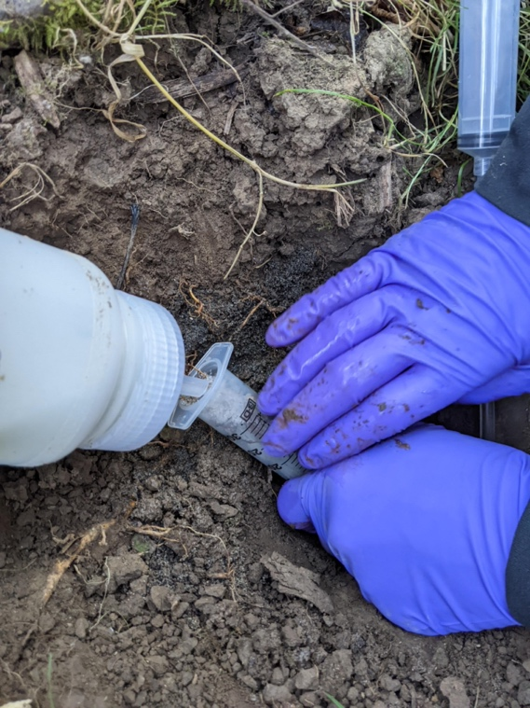

Figure 7. Filling incubation assembly around root with fine glass beads.

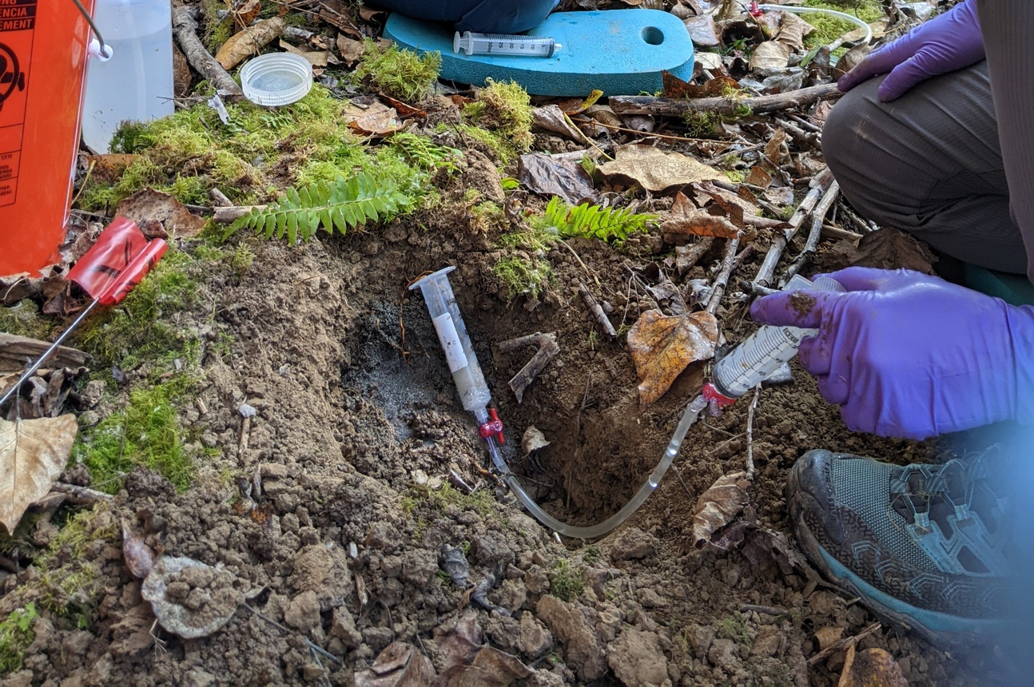

Figure 8. Injecting nutrient solution into the bottom of the incubation assembly (note that this earlier version of the assembly lacks a syringe filter, and features 1/8" ID tubing instead of 1/16").

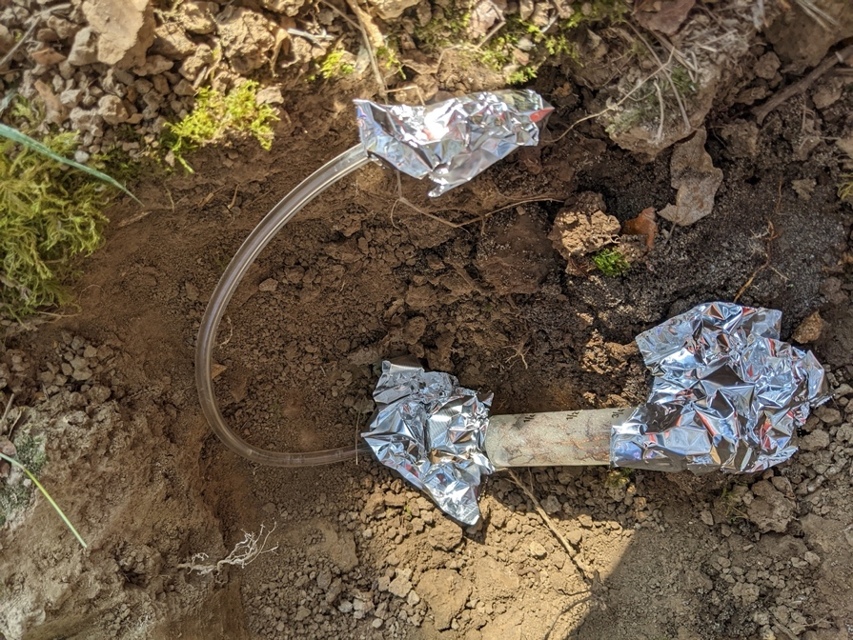

Figure 9. Completed incubation assembly.

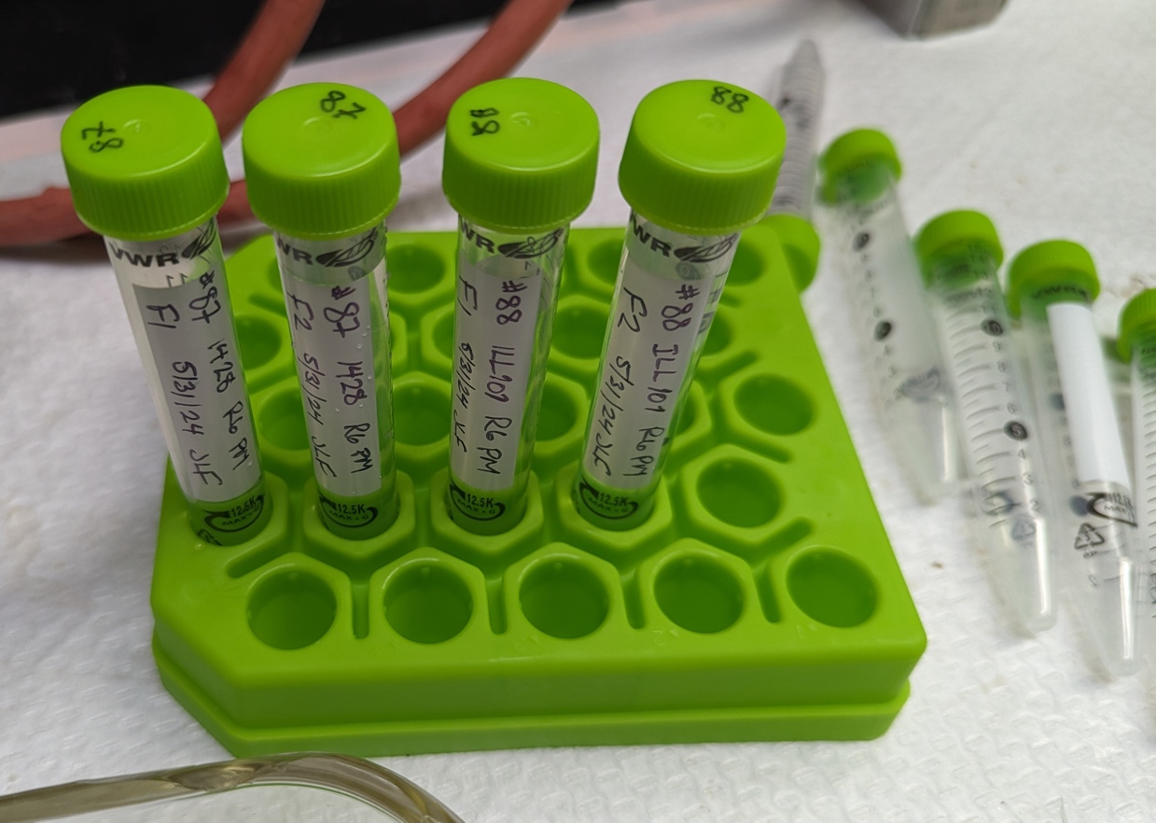

Figure 10. Flush sample storage in 15 mL "Falcon" tubes (VWR brand)

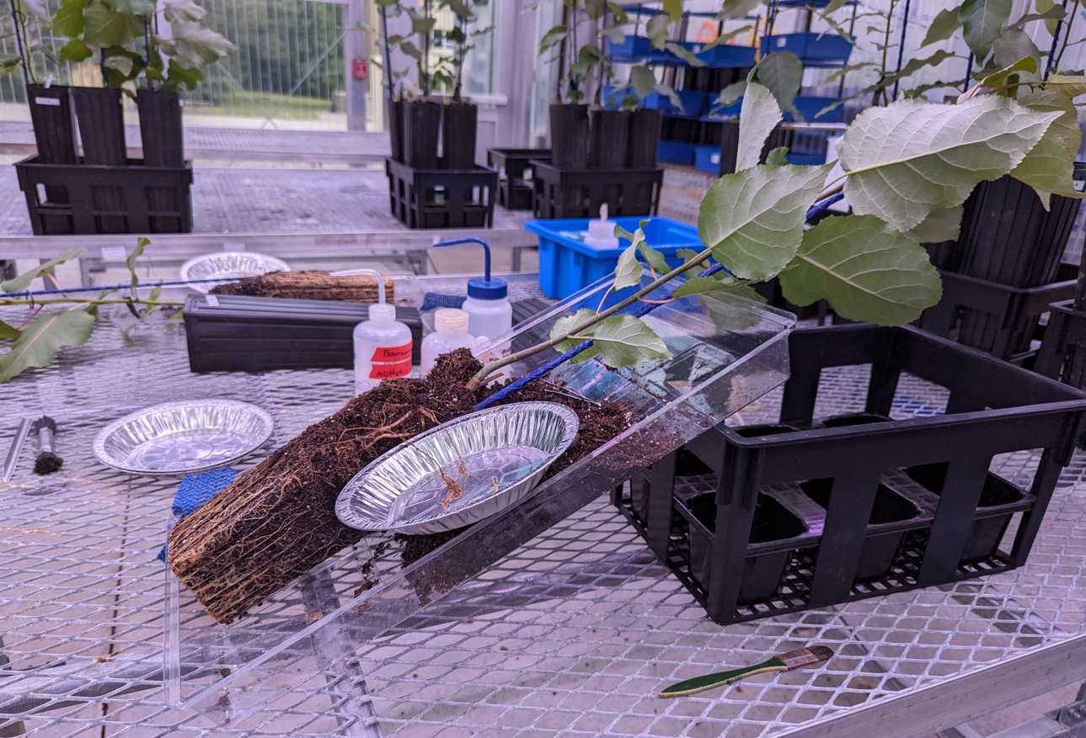

Figure 11. Root excavation from a poplar plant grown in potting mix in the greenhouse. The root/soil "plug" has enough structure that it can be removed from the pot intact, and reassembled later.

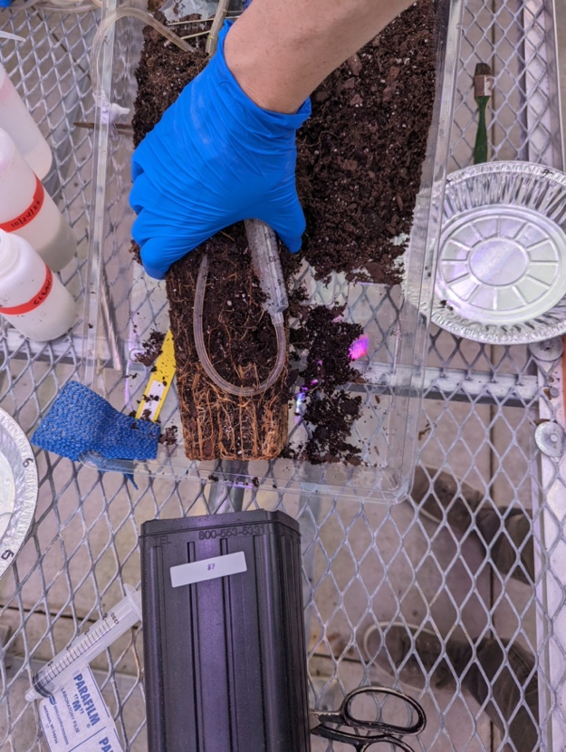

Figure 12. Adding a 20 mL incubation assembly the to the root/soil plug, routing the solution collection tube to the top of the soil surface, and returning the entire assembly back to the original pot.

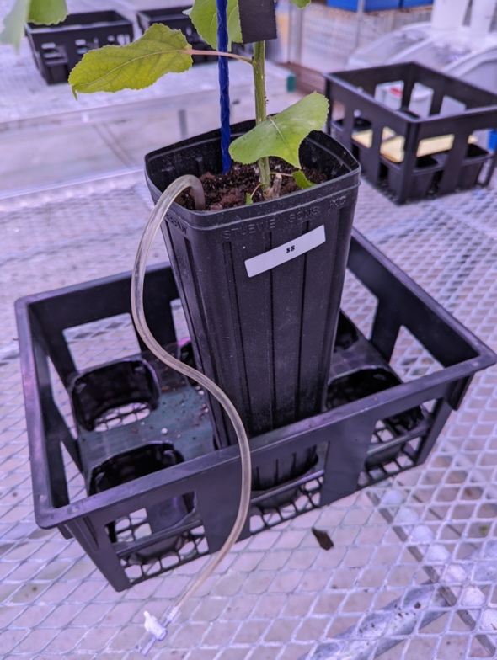

Figure 13. Re-potted plant with sample collection tube protruding from the surface. A shorter and narrower tube would reduce the amount of "dead" volume that needs to be managed.

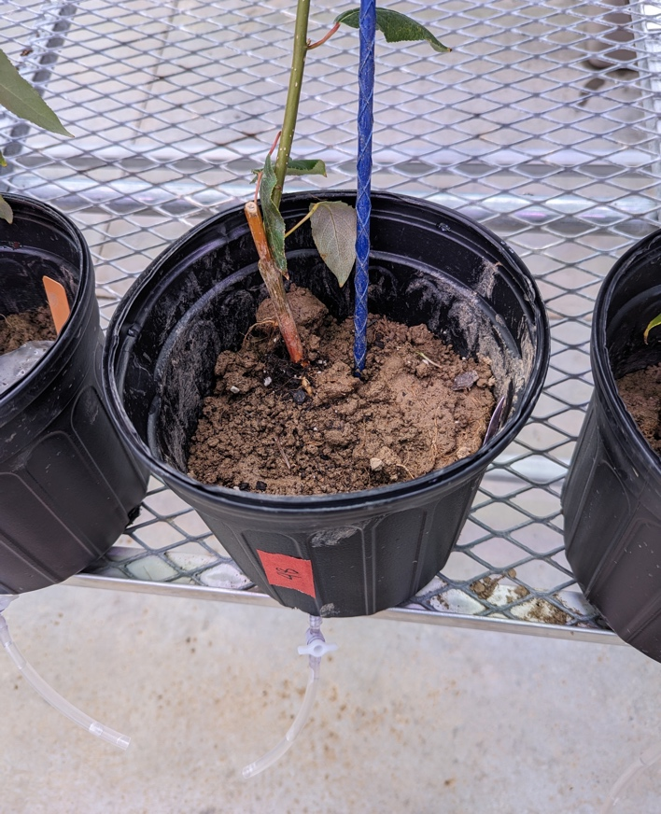

Figure 14. Relatively young plants grown in field soil may lack enough root/soil "plug" structure to facilitate reassembly in the original tall/skinny pot. In these cases, the plant can be transferred to a wider pot, routing the end of the incubation syringe out a drainage hole, and twisting/folding the remaining root/soil plug to fit.

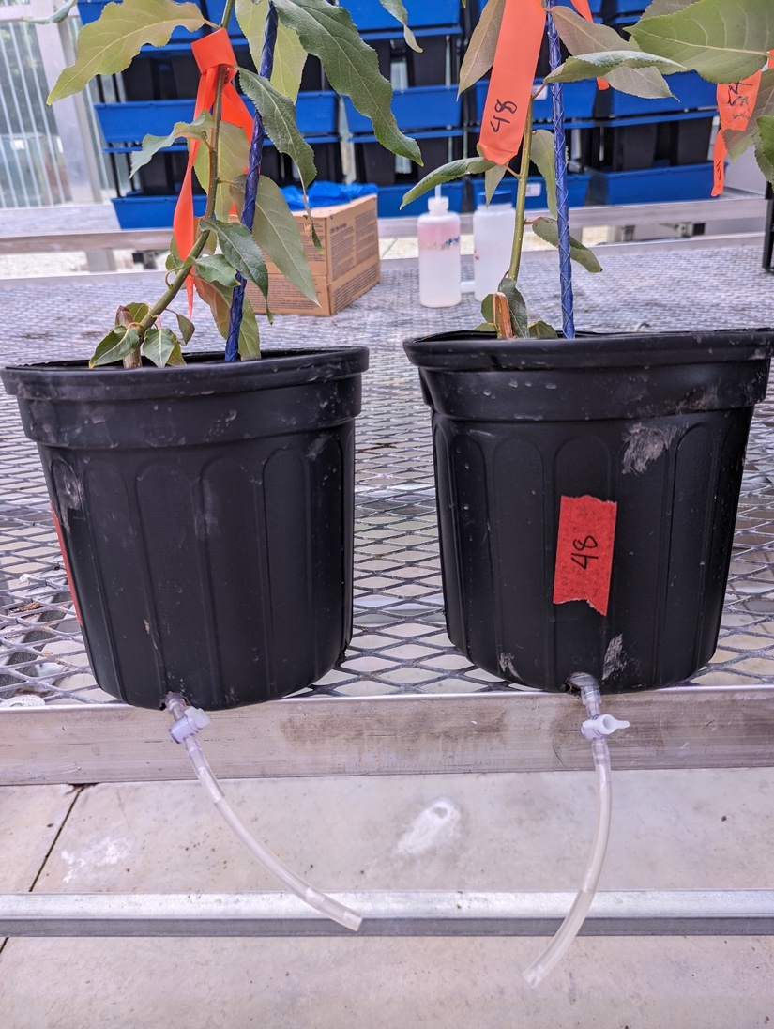

Figure 15. Another view of the incubation syringe protruding from the bottom of the new, wider pot.